**Way of Being Inventory**

|  |  |  |  |  |  |  |  |  |
| --- | --- | --- | --- | --- | --- | --- | --- | --- |
| The purpose of this survey is to measure how mindful you have been lately (vs. absentminded) and how much you tend to think about the greater meaning of your life (vs. the ‘everyday’). This inventory consists of 18 statements about your recent experiences and you are asked to rate how frequently or infrequently you have had these experiences. Please answer according to what really reflects your experiences, rather than what you think your experiences should be. Please treat each item separately from every other item. | |  | | --- | | **Rank System** | | 1 = Almost Always | | 2 = Very Frequently | | 3 = Somewhat Infrequently | | 4 = Somewhat Frequently | | 5 = Very Infrequently | | 6 = Almost Never | |

|  |  |  |
| --- | --- | --- |
|  | Recently at work... | RANK |
| 1 | I make basic mistakes because of carelessness, not paying attention, or thinking of something else. |  |
| 2 | I value getting things done over finding deeper purpose (i.e. meaning) in what I am doing. |  |
| 3 | I find it difficult to stay focused on the present moment during meetings. |  |
| 4 | I get so busy that I forget to stop and appreciate life. |  |
| 5 | I find myself listening to a coworker with one ear, and doing something else at the same time. |  |
| 6 | I ask myself "How many tasks can I accomplish before the day is through?" |  |
| 7 | I rush through activities without being paying close attention to them. |  |
| 8 | I get consumed by worries that I won't get everything done. |  |
| 9 | I fail to notice how I am feeling when speaking with a coworker. |  |
| 10 | I put job responsibilities above caring for myself and others. |  |
| 11 | I complete tasks automatically, without being aware of what I'm doing. |  |
| 12 | I forget that we only have one life to live. |  |
| 13 | I find myself preoccupied with the future or the past. |  |
| 14 | I judge my days by how much work I finish. |  |
| 15 | I find my mind wandering as if "by itself" when working. |  |
| 16 | I find myself preoccupied with making sure others complete their work rather than helping them find deeper meaning in their work. |  |
| 17 | I commute to and from work on "auto-pilot" without remembering what most of the trip was like. |  |
| 18 | I go through my day as if I will live forever. |  |

**Plot your Way of Being**

|  |  |  |  |  |
| --- | --- | --- | --- | --- |
| **Question Number** | **Your**  **Score** |  | **Question**  **Number** | **Your Score** |
| **2** |  |  | **1** |  |
| **4** |  |  | **3** |  |
| **6** |  |  | **5** |  |
| **8** |  |  | **7** |  |
| **10** |  |  | **9** |  |
| **12** |  |  | **11** |  |
| **14** |  |  | **13** |  |
| **16** |  |  | **15** |  |
| **18** |  |  | **17** |  |
| **TOTAL MOE** |  |  | **TOTAL MOA** |  |

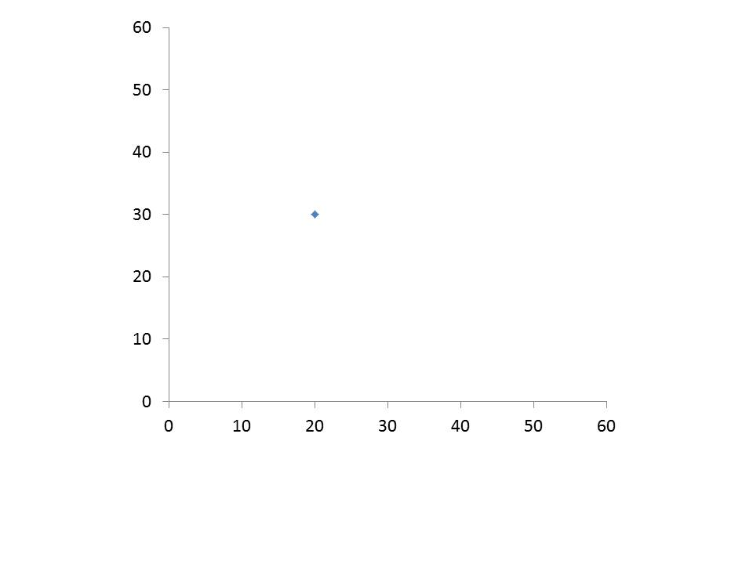

Yearning

Plot **Total MOE** on this axis

Plot **Total MOA** on this axis

Transcending

Transforming

Habituating